BSEN 5520 Lab 7
Victoria Burnett

The first step in hydrologic modeling involves delineating streams and watersheds and getting basic watershed properties such as area, slope, flow length, stream network etc. This is done through ArcGIS using Arc Hydro tools to process a DEM to delineate the watershed. The results are then used in HEC-HMS hydrologic model.
March 16, 2015
Auburn university
BIOSYSTEMS ENGINEERING

INTRODUCTION
The data files used in this exercise consist of DEM grid for Cedar Creek in northeast Indiana and the hydrography data. ArcGIS is used to delineate the watershed and stream network using the Arc Hydro tools and then importing the data into HEC-HMS.

PROCEDURE
- Using the laboratory instructions, load the data into ArcMap.
- Perform all terrain preprocessing using Arc Hydro. This includes DEM reckoning, Fill sinks, flow direction, flow accumulation, stream definition, stream segmentation, catchment grid delineation, catchment polygon processing, drainage line processing, adjoint catchment processing, drainage point processing and slope.
- Perform all Watershed Processing. This includes batch point generation and batch watershed delineation.
- Perform remaining Terrain Processing and HMS-Model development using GeoHMS. This includes basin processing, merging basins, river lengths, river slopes, longest flow paths, basin centroids, basin centroid elevations and centroidal longest flow paths.
- Complete all HMS Input/Parameters by selecting HMS processes and manually entering sub-basin characteristics.
- Export Data into HEC-HMS project and open in HEC-HMS.

RESULTS
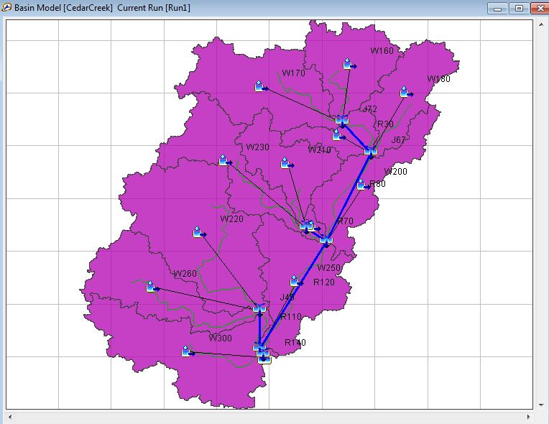
Figure 1. Watershed Delineation Image
Figure 1 shows the watershed sub-basins (in purple), the longest flow paths (in green), the reaches (in blue) and the outlet (bottom right corner).
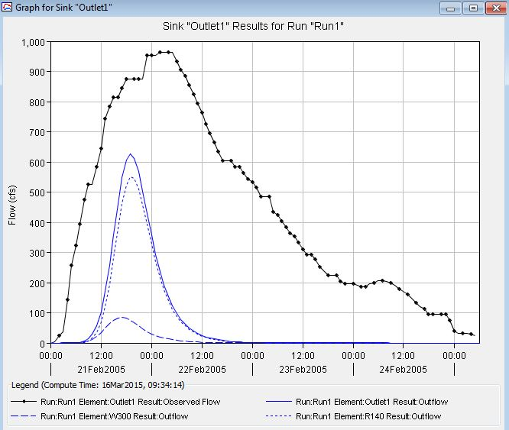
Figure 2. Original Hydrograph for Cedar Creek
Figure 2 above shows the watershed outlet observed outflow, in black, and the simulated outflow, in blue. The observed peak discharge is significantly higher than the simulated peak discharge. The observed flow time is also significantly longer (starting at time 00:00 on Feb 21 and ending at 06:00 on Feb 25) than the simulated outflow time (starting at 06:00 on Feb 21 and ending at 00:00 on Feb 23).
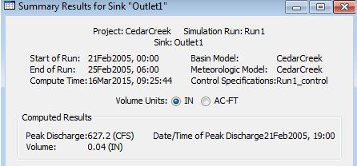
Figure 3.Original Outlet Summary Results for Cedar Creek
The outlet summary results for cedar creek also indicate a simulated peak discharge of 627 cfs and a volume of 0.04 inches, as shown in figure 3. The date and time of peak discharge is Feb 21, 2005.
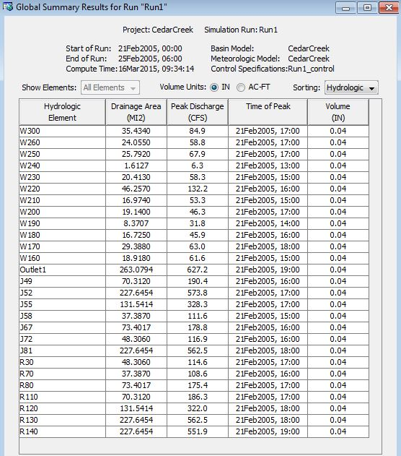
Figure 4. Original Global Summary Results for Cedar Creek
Figure 4 shows the global summary for cedar creek in the original simulation run. All the hydrologic elements are shown, with their respective drainage areas, peak discharges, time of peaks and volumes.
An optimization trial was run to calibrate the model to better fit the observed data. The following results are shown below in figure 5, figure 6 and figure 7.
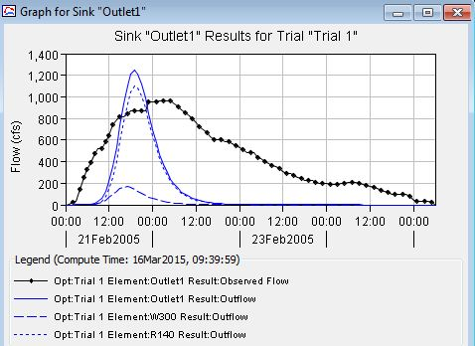
Figure 5. Outlet Hydrograph during Optimization in Cedar Creek Watershed
Figure 5 shows the outlet hydrograph during the optimization trial. The dotted black line is the observed data while the blue lines represent the optimization outflows. The optimized outflow peaks an hour prior to the observed outflow and is approximately 200 cfs greater. The observed flow also flows much longer than the optimized outflow.
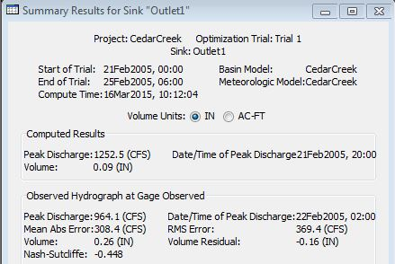
Figure 6. Outlet Summary Results during Optimization in Cedar Creek
Figure 6 shows the outlet summary results during the optimization trial. The optimized peak discharge is 1252 cfs, while the observed peak discharge is 964 cfs. This means the optimized peak discharge is approximately 300 cfs greater than the observed peak discharge, with 370 cfs of rms error. The optimized volume is 0.09 inches, which is much lower than the observed volume of 0.26 inches.
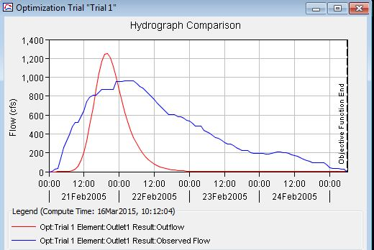
Figure 7. Outlet Hydrograph during Optimization in Cedar Creek Watershed
Figure 7 shows the outlet hydrograph comparison during the optimization trial. This is similar to the results shown in figure 5, having the observed hydrograph with much higher volume and lower peak discharge.
A simulation run was then performed again with various parameters manually changed to try to manually fit the simulated outflow to the observed outflow data, without using the optimization trial. This resulted in better alignment than the optimization trials. This is shown below in figure 8 and figure 9.
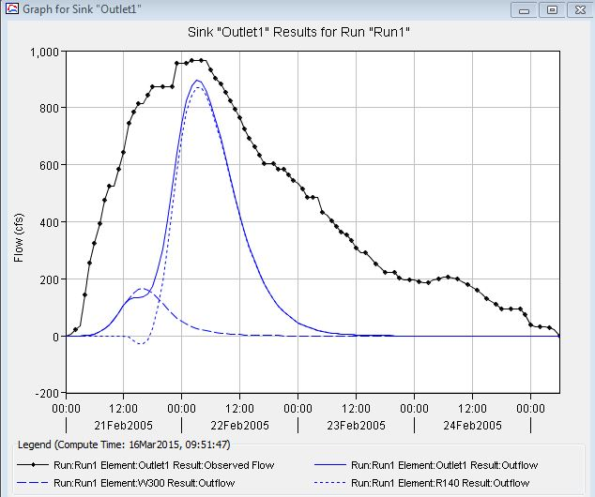
Figure 8. Outlet Hydrograph with Manually Changed Parameters
Figure 8 shows the effects of manually changing parameters in cedar creek watershed. The simulated peak discharge increased to be much closer to the observed peak discharge, while having the same peak discharge time of about 06:00 on Feb 22.
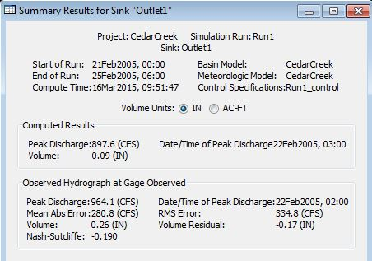
Figure 9. Changed Parameters
Figure 9 above shows the summary results of the outlet during the simulation run with manually changed parameters. This verifies the analysis from figure 8. The simulated peak discharge of 900 cfs was much closer to the observed peak discharge of 960 cfs than the optimized peak discharge of 1200 cfs. The volume is still much lower in the simulated outflow than to the observed outflow.

CONCLUSION
Optimization trails were run using six parameters. All sub-basins were optimized using the SCS curve number scale factor and the SCS curve number initial abstraction scale factor. The two largest reaches, R120 and R80, were also optimized using the Muskingum K and Muskingum X values. Overall, the optimization trials performed were successful but inaccurate in representing the observed data.
The simulation run was then performed again after manually changing parameters. These changed parameters include the Muskingum storage constant (HR), Muskingum weighting factor (X), impervious area, initial abstraction and curve numbers. The Muskingum HR was originally set at zero and was changed to 4. The Muskingum x was originally 0.2 and was changed to 0.5. The impervious area of a watershed would usually be a value higher than zero, due to roads or houses, depending on the area, so the impervious area was changed from zero to 25%. Some water will also infiltrate into the soil and vegetation, allowing for an initial abstraction greater than 0, so the initial abstraction value was changed from zero to 0.6 inches. These parameters changed allowed for a similar simulated peak flow to the desired peak flow rate of 970 cfs and the same time of peak. The volume of the simulated outflows and the observed outflows remained having a difference greater than 10 inches.

