BSEN 5220 - CASE STUDY ASSIGNMENT 1 & 2
Victoria Burnett
October 22, 2014
Auburn university
BIOSYSTEMS ENGINEERING

Abstract
In this assignment, students learn how to navigate through ArcGIS’s ArcCatalog and ArcMap with their own data collection. After obtaining raw data, the projection process is explored. The result is high quality data with one coordinate coordinate system that can be viewed in ArcMap for analysis. The next part of the assignment allows students to create contours and export them into ACAD. The final objective is to have a set of quality data for future assignments.

ASSIGNMENT 1
Data Collection
INTRODUCTION
This assignment is performed to introduce students to data collection for GIS-related problems. All the data in past assignments have been given to students to use with this software. In reality, there is not previously downloaded and projected data for a site. By downloading and projecting data, students will learn about the quality of data. The better quality data that is used, the better the projection into a 2-dimensional layout will be, thus having better analysis. The source used to obtain the DEM (3 x 3 meter resolution), orthoimagery (aerial image 1 x 1 meter resolution), land cover (2011), and topographic map (2011) data were all found on the USGS National Map Viewer website. The soil data shapefile was found on the USDA Web Soil Survey website. Once all the data is obtained, the data is projected using ArcCatalog and then imported into ArcGIS in the Alabama State Plane East Coordinate System. Screen captures are taken as needed to completion of the assignment.
PROCEDURE
PREPARATION AND DATA PROJECTION
- Open ArcCatalog
- Find data to be projected
- Open ArcToolbox
- Navigate to ‘Project’ or ‘Batch Project’ (if there are multiple files). This can be done through Data Management > Projections and Transformations > Feature
- Select new coordinate system (i.e. UTM Zone 16N, Alabama State Plane East, etc.)
- Process the data and wait for new data to appear. This step could take several minutes.
- Check the projected data properties to see if the coordinate system has changed

RASTER DATA PROJECTION
- Navigate to ‘Project Raster’ through Data Management > Projections and Transformations > Raster
- Select new coordinate system (i.e. UTM Zone 16N, Alabama State Plane East, etc.)
- Select resampling technique (i.e. Nearest, Bilinear, etc.)
- Process the data and wait for the new data to appear. This process may take several minutes to complete.
- Check the projected data properties to see if the coordinate system has changed

IMPORT DATA INTO ARCMAP
- Close ArcCatalog and Open ArcMap. Add the projected data. Keep in mind that ArcMap automatically makes the coordinate system of the first data added the coordinate system of the data frame.
- Check the data frame properties to see that the coordinate system of the data frame is the desired coordinate system. Check the properties of each piece of data for the correct coordinate system. Avoid “defining” a new coordinate system because that does not actually convert the data.
- Turn on background processing to see the progress of all processes. This will prevent you from interrupting a process that you think is already completed. If it is interrupted, you will lose the new data, and may cause the program to freeze.
- Changes are permanent and are hard to reverse if you are not familiar with the software. If you make a mistake with original data you will have to download it again.
RESULTS
After the data was collected and projected, the coordinate systems were verified. By checking the coordinate system within ArcCatalog and again in ArcMap, it is verified that they match. This is shown in Figure 1 and Figure 2 below.
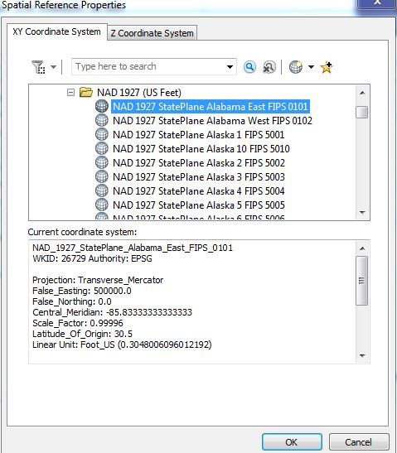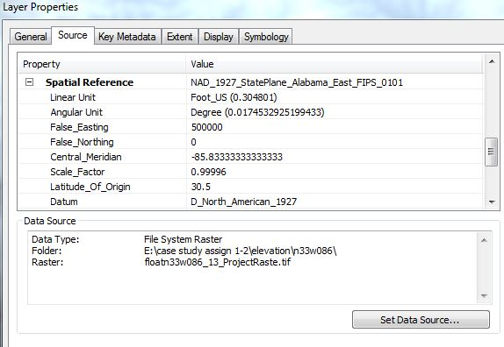
Figure 1 – ArcCatalog Coordinate System Figure 2 – ArcMap DEM layer Coordinate System
This metadata shows the details of the data, which is a transverse mercator projection, East Alabama state plane coordinate system, with the 1927 North American Datum. Every data layer matches, ensuring that the projection was a success, and allows all the data to be projected accurately within ArcMap. The layer properties for all data in ArcMap can also be seen through the layer properties below in Figure 4. These were found in the properties of the data frame. This shows the projection, coordinate system and datum for all layers.
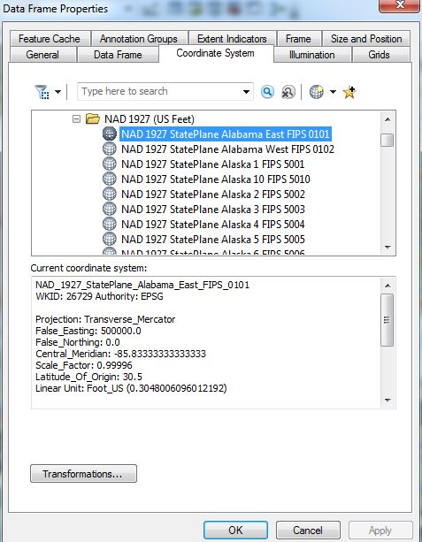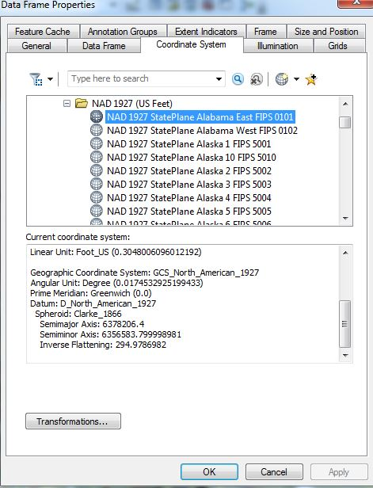
Figure 4 – Data Frame Properties
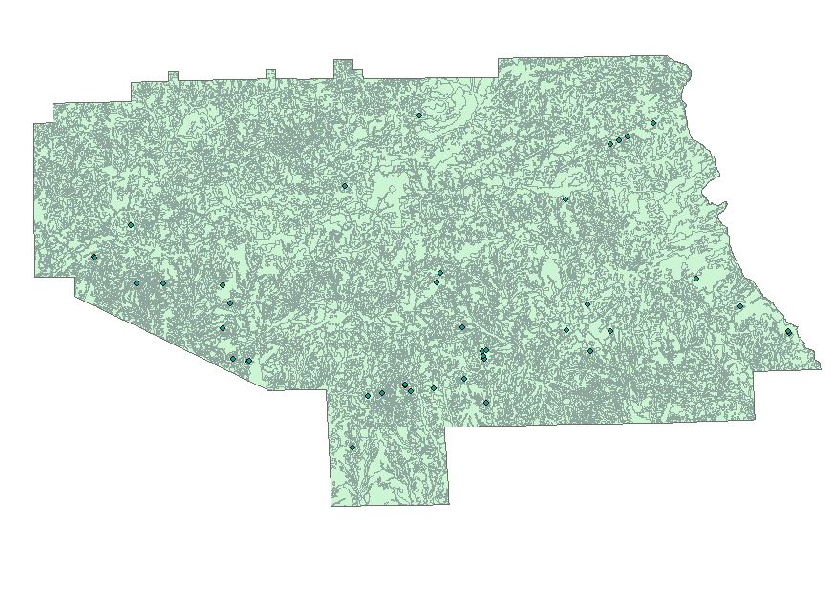
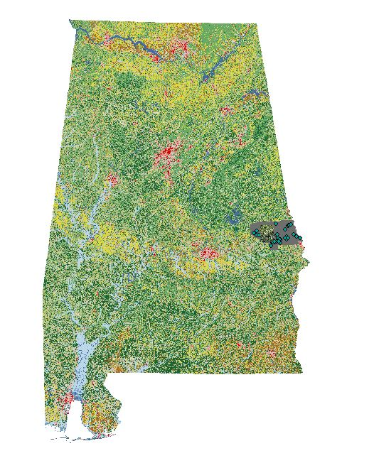
Figure 4 – State of Alabama Land Cover Layer in ArcMap Figure 5 – Lee County Soil Layer
The resulting data that was imported into GIS’s ArcMap is displayed in Figure 4. The state of Alabama is shown through the land cover layer. On the far right side of the Alabama, in Figure 4, there is a darker section of the state. This is the soil layer and the orthoimagery (aerial) layer. The soil layer for Lee County is shown closer in figure 4. A closer look at the aerial and the DEM layers are shown below.
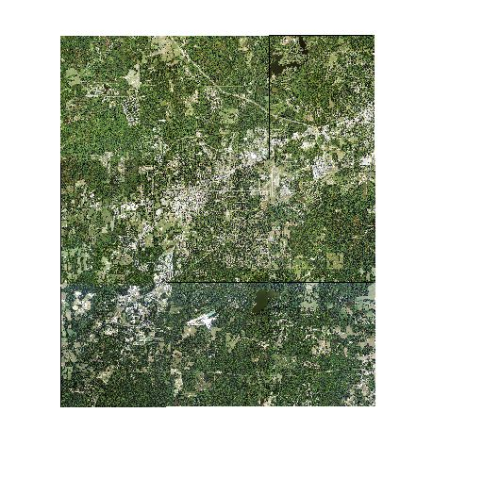
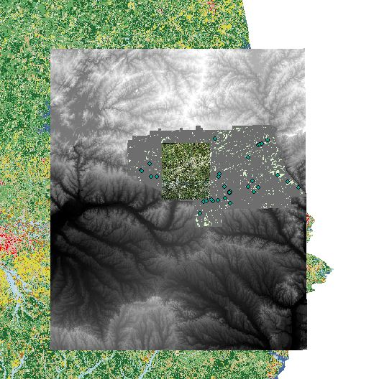
Figure 6 – Lee County and Surrounding DEM (elevation) layer Figure 7 – Orthoimagery (Aerial) Image of Lee County
In Figure 6, the DEM layer can be seen as the black to grey gradient. Inside the DEM, the outline of the soil layer can be seen. In the very middle of the DEM layer in Figure 6, there is a small aerial block. This aerial image of Lee County is shown in closer detail in Figure 7 above.
The metadata contains all the information about data, including the applications and specifications. It includes who collected the data, the purpose of the data collection, how the data was collected and its parameters. It is the data of the data, and is shown in a text file. This is not to be confused with the metadata that is shown in the projected coordinate system, which also shows the data’s orgins. This was also explored, as shown in Figure 7.
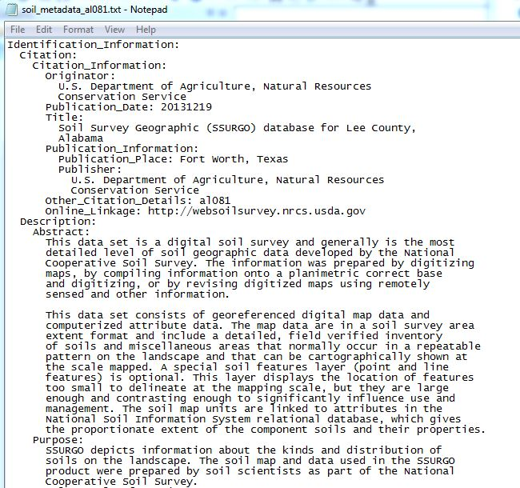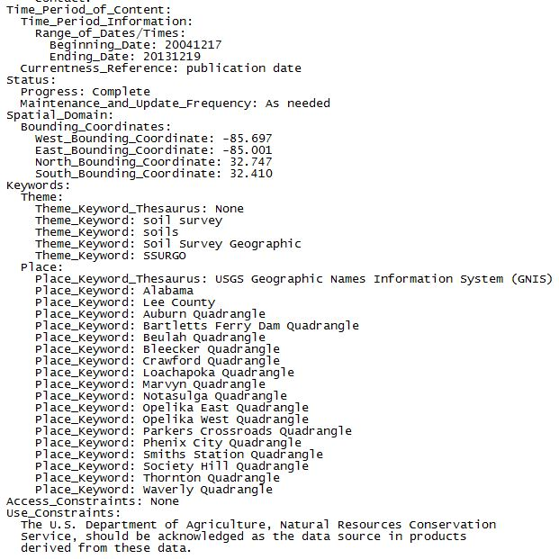
Figure 9- Metadata Text file that includes all the data of the data
The US topography map is also shown in the appendix to show the topography of the area as well as what a GIS map should look like.
CONCLUSION
Especially after the computer crashed numerous times, I feel more comfortable using ArcMap. I learned that the projection was very important. The projection system allows ArcMap to define the projection of undefined files. I accidentally did not project the DEM layer the first time I collaborated data. The DEM had a completely different reference point (from its original coordinate system) and did not line up with any of the other projected data, even though it originated from the same geographical location and was downloaded from the same website. A different coordinate system for the same location completely changed the data location (as shown in ArcMap.)
Organization also plays a key role in the projection process. There were several times I projected the same data and then wondered why it was only loading half the data in ArcMap and the other half was “not projecting.” The problem was either I projected the wrong data file, or I didn’t project it accurately into the same coordinate system as the rest of the data, causing it to be elsewhere in ArcMap from the viewer space. All shape files already have a projection, whether it is defined or not, so it is important to know the projection that the rest of the data is using and make sure they line up.

ASSIGNMENT 2
Data Preparation and Management – Exporting Data to ACAD
INTRODUCTION
This assignment allows students to generate their own contours in ArcMap and then export the data into AutoCAD. Using the DEM that was previously acquired in assignment 1, contour data is generated with 2-foot, 10-foot, and 1-meter intervals. Once each of these are created, each are overlaid onto the aerial image used in assignment 1. The coordinate system is also checked to ensure proper projection. After generated, the 3 contours are exported into AutoCAD. Ultimately several maps will be drawn including a title block and information pertaining to the map.
PROCEDURE
To export contours, you must ensure there exists a field titled ‘ELEVATION’ in the attribute table. This can be done through the following steps.
- Right click on the contour layer, and click Open Attribute Table. If this field does not exist, click Options > Add Field.
- Under ‘Name’ type “Elevation”, and under ‘Type’ select. Enter a field size of 10. Click ok.
- Right click on the new ‘Elevation’ column and select ‘ Field Calculator’. Click yes to continue without being in an ‘edit session’. Note that if you get this message it is indicating that you are not currently in edit mode and that no undoes are possible.
- Double-click the Field that contains the elevation data for the contours that will be added to the new ‘Elevation’ column. Press OK. The new Elevation column will now contain the contour elevation data.
EXPORTING ARCMAP TO AUTOCAD
- Go to Conversion Tools in ArcToolbox.
- Click “To CAD” then “Export to CAD”
- Under Input Features, navigate to find the contour layer that will be exported to CAD. Click on Output File and select the location or filename where AutoCad file will be saved. Press Ok. If you would like to add the contours to an existing ACAD file, check “append to existing files.”
- The new ACAD file (.dwg) is now ready to be opened in AutoCAD.
RESULTS
The contours were made first using the DEM (elevation) raster as the input raster and defining the contour intervals. This process is shown below in Figure 1. The z-factor used was 3.28084, because there are 3.28084 feet in one meter. This is because our values were in meters originally. The projection process changed our data’s x and y values (latitude and longitude) from meters to feet, but it did not include the z (elevation/height) values. The contour z-factor corrects this. This process is shown in Figure 1.
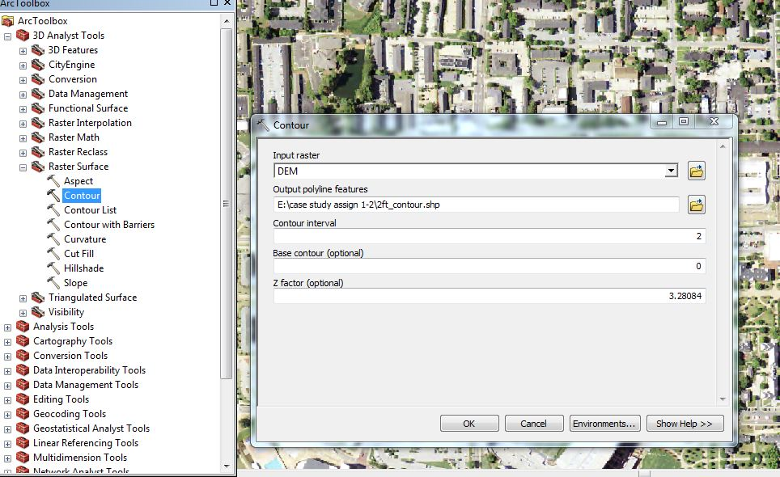
Figure 1 – Creating Contours in ArcMap
There were 2-foot contours, 10-foot contours, and 1-meter contours drawn. After the contours were drawn, an elevation field was added for each contour. This is done so AutoCAD can use the specific elevation field to define the contours. This process is shown below in Figure 2.
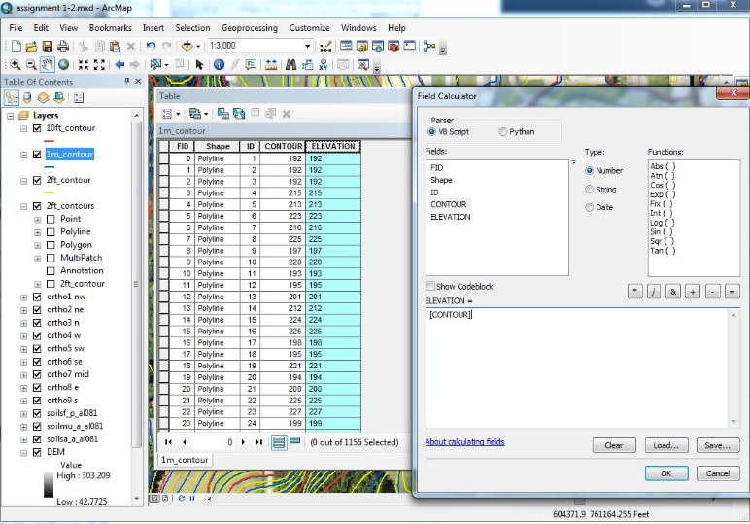
Figure 2 – Elevation Field Addition to Contour Properties
After this process was complete, the 2-foot contours were exported into AutoCAD. There are PDF’s of each of the contours, as well as the 2-foot contours and an aerial map in AutoCAD attached to the end of the report in the appendix.
CONCLUSION
It was learned that if the z-factor is not set correctly when creating contours, data hillsides will look heavy or leaden because it assumes the linear unit of measurement is the same as the height unit of measurement. Using the incorrect z-factor will also make the slope values significantly smaller than the accurate slope value. The contours were first drawn by only changing the interval size and not the z-factor. This was incorrect because by just altering the intervals it only stretched the DEM layer, without correcting the height loss when it was stretched.
Creative aspects were explored when making maps in ArcMap. The background colors for the legend and neatlines were changed. Neatlines were found to be a little difficult because several neatline blocks were created and then put side-by-side to create one huge box. Later I learned that you can create one huge neatline and then put smaller boxes into the large one, which resulted in more organized text beneath the map.
The process of exporting the 2-foot contours into an AutoCAD drawing taught me how to overlay an aerial jpeg file beneath previously imported contours. The process of importing an image into AutoCAD is to type “IM” to access the file references and click add image. This was interesting because only PNG files can be made transparent. Other files can be added, but do not have the color image with a transparent layer that can be made dimmer in AutoCAD.
APPENDIX
A-1: Assignment 1 Topography PDF
A-2: Assignment 2 GIS Map with 2-foot, 10-foot, and 1-meter contours
A-3: Assignment 2 GIS Map with 2-foot contours
A-4: Assignment 2 GIS Map with 10-foot contours
A-5: Assignment 2 GIS Map with 1-meter contours
A-6: Assignment 2 AutoCAD PDF with 2-foot contours and aerial map

